SQL PROJECT
Case Study

Case Study Description
This project presents a comprehensive SQL-based case study conducted on a structured retail dataset (Sample Superstore), designed to simulate real-world business scenarios. The primary objective of this analysis was to explore the data, write efficient and optimized SQL queries, and generate meaningful insights that support business decision-making.
The case study involves performing detailed data exploration to understand the dataset structure, followed by applying filters, joins, aggregations, and subqueries to answer key business questions related to sales performance, profit trends, customer segments, product categories, and regional performance. Time-based analysis was also carried out to identify trends and patterns across different periods.
Throughout this project, core SQL concepts such as INNER and OUTER JOINs, GROUP BY and HAVING clauses, subqueries, date functions, and conditional logic were extensively used. The analysis focuses on transforming raw transactional data into clear, actionable insights that reflect practical retail and business analytics use cases.
This project helped strengthen my SQL skills and enhanced my ability to think analytically, interpret business requirements, and convert them into effective SQL queries for data-driven decision-making.

CASE STUDY
- Import the dataset and do usual exploratory analysis steps like checking the structure & characteristics of the dataset.
- Data type of all columns in the “customers” table.
Hint: We want you to display the data type of each column present in the “customers” table.
SYNTAX:
SELECT
column_name,
data_type
FROM
`case_study.INFORMATION_SCHEMA.COLUMNS`
WHERE
table_name = 'customers';

RESULT:
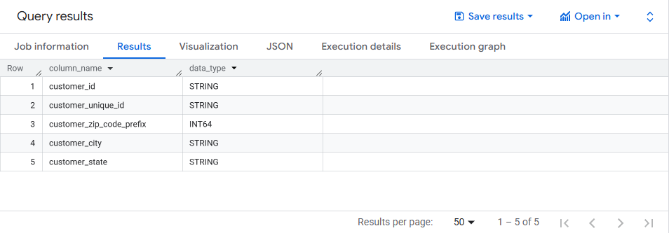

B. Get the time range between which the orders were placed.
Hint: We want you to get the date & time when the first and last orders in our dataset were placed.
SYNTAX:
SELECT
MIN (order_purchase_timestamp) as mini_timerange,
MAX (order_purchase_timestamp) as max_timerange
FROM `case_study.orders`;

RESULT:
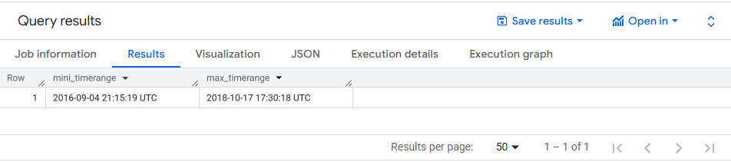

C. Count the Cities & States of customers who ordered during the given period.
Hint: We want you to count the number of unique cities & states where orders were placed by the customers during the given time period.
SYNTAX:
SELECT
C.customer_state,
C.customer_city,
COUNT(O.order_id) AS total_orders
FROM `case_study.customers` AS C
JOIN `case_study.orders` AS O
ON C.customer_id = O.customer_id
GROUP BY C.customer_state, C.customer_city;

RESULT:
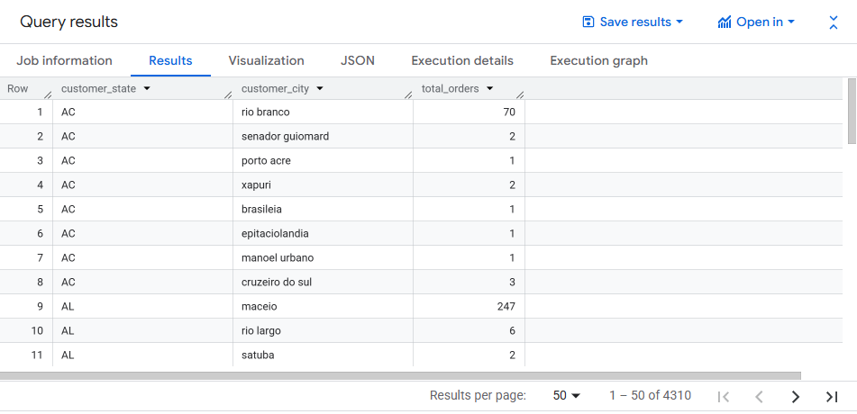

II. In-depth Exploration:
- Is there a growing trend in the no. of orders placed over the past years?
Hint: We want you to find out if no. of orders placed has increased gradually in each month, over the past years.

SYNTAX:
SELECT
EXTRACT(Year FROM order_purchase_timestamp) as order_year,
EXTRACT(Month FROM order_purchase_timestamp) as order_month,
COUNT(order_id) as total_order
FROM `case_study.orders`
GROUP BY order_year, order_month
ORDER BY order_year, order_month;

RESULT:
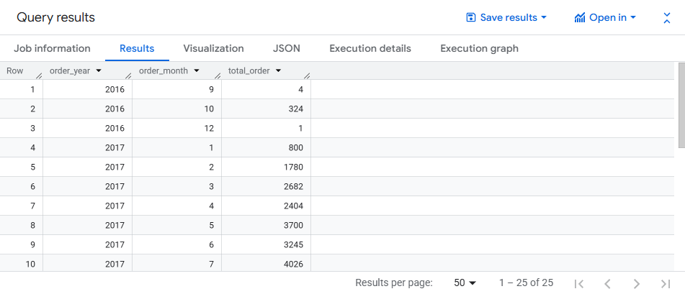

- Can we see some kind of monthly seasonality in terms of the no. of orders being placed?
Hint: We want you to find out if the no. of orders placed are at peak during certain months.

SYNTAX:
SELECT
EXTRACT(Month FROM order_purchase_timestamp) as order_Month,
COUNT(order_id) as total_orders
FROM `case_study.orders`
GROUP BY order_Month
ORDER BY order_Month;

RESULT:

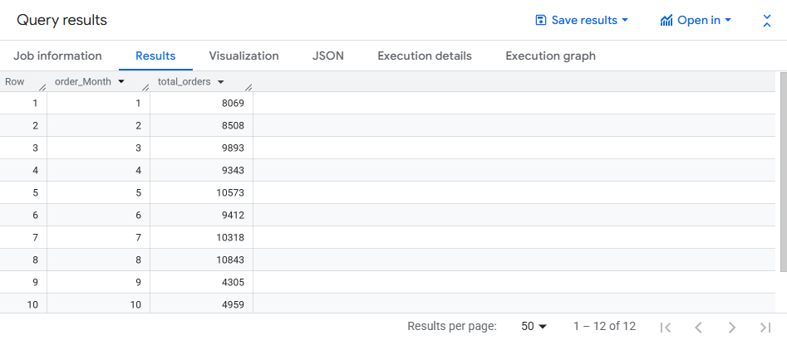

C. During what time of the day, do the Brazilian customers mostly place their orders? (Dawn, Morning, Afternoon or Night)
● 0-6 hrs: Dawn
● 7-12 hrs: Mornings
● 13-18 hrs: Afternoon
● 19-23 hrs: Night
Hint: We want you to categorize the hours of a day into the given time brackets/ intervals and find out during which intervals the Brazilian customers usually order the most.

SYNTAX:
SELECT
CASE
WHEN EXTRACT(Hour FROM order_purchase_timestamp) BETWEEN 0 AND 6 THEN 'Dawn'
WHEN EXTRACT(Hour FROM order_purchase_timestamp) BETWEEN 7 AND 12 THEN 'Mornings'
WHEN EXTRACT(Hour FROM order_purchase_timestamp) BETWEEN 13 AND 18 THEN 'Afternoon'
WHEN EXTRACT(Hour FROM order_purchase_timestamp) BETWEEN 19 AND 23 THEN 'Night'
END as time_period,
COUNT(order_id) as total_orders
FROM `case_study.orders`
GROUP BY time_period
ORDER BY total_orders;
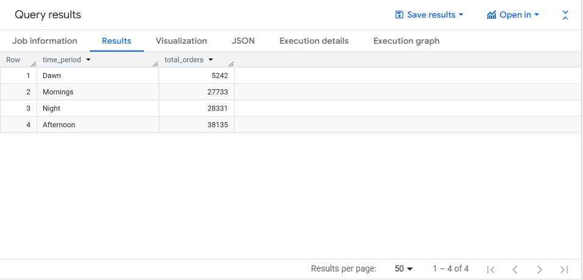

III. Evolution of E-commerce orders in the Brazil region:
- Get the month-on-month no. of orders placed in each state.
Hint: We want you to get the no. of orders placed in each state, in each month by our customers.
SYNTAX:
SELECT
C.customer_state AS state,
EXTRACT(MONTH FROM O.order_purchase_timestamp) AS Month,
COUNT(*) AS No_of_Orders
FROM `case_study.orders` AS O
JOIN `case_study.customers` AS C
ON O.customer_id=C.customer_id
GROUP BY Month, state
ORDER BY Month, state;

RESULT:
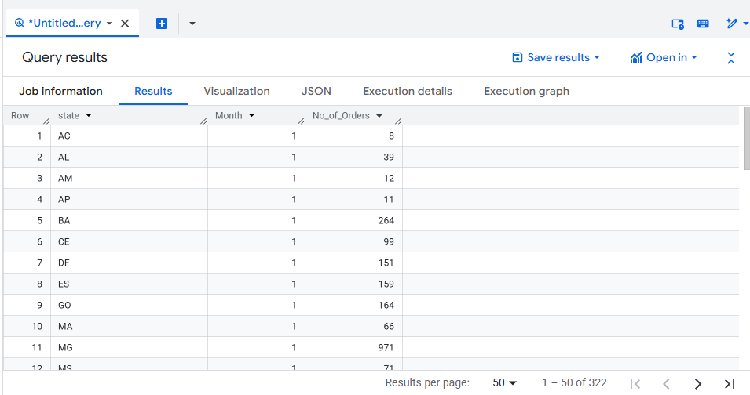

- How are the customers distributed across all the states?
Hint: We want you to get the no. of unique customers present in each state.

SYNTAX:
SELECT C.customer_state,
COUNT(distinct C.customer_unique_id) as no_of_uniqueid
FROM `case_study.customers` as C
GROUP BY C.customer_state
ORDER BY no_of_uniqueid DESC;

RESULT:
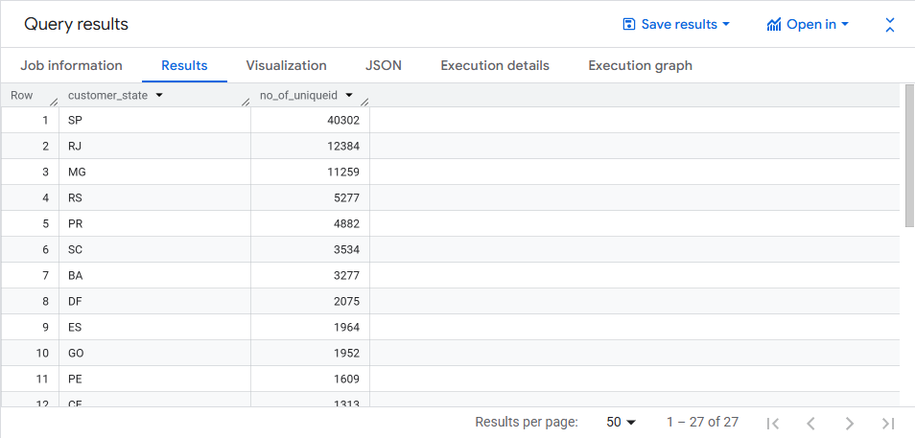

IV. Impact on Economy: Analyse the money movement by e-commerce by looking at order prices, freight and others.
- Get the % increase in the cost of orders from year 2017 to 2018 (include months between Jan to Aug only).
Hint: You can use the payment_value column in the payments table to get the cost of orders.
SYNTAX:
WITH yearly_cost AS (
SELECT
EXTRACT(YEAR FROM o.order_purchase_timestamp) AS order_year,
SUM(p.payment_value) AS total_order_cost
FROM `case_study.orders` o
JOIN `case_study.payments` p
ON o.order_id=p.order_id
WHERE EXTRACT(MONTH FROM o.order_purchase_timestamp) BETWEEN 1 AND 8
AND EXTRACT(YEAR FROM o.order_purchase_timestamp) IN (2017,2018)
GROUP BY order_year
)
SELECT
((c2018.total_order_cost-c2017.total_order_cost)/c2017.total_order_cost)*100
AS percentage_increase
FROM yearly_cost c2017
JOIN yearly_cost c2018
ON c2017.order_year=2017
AND c2018.order_year=2018;
RESULT:
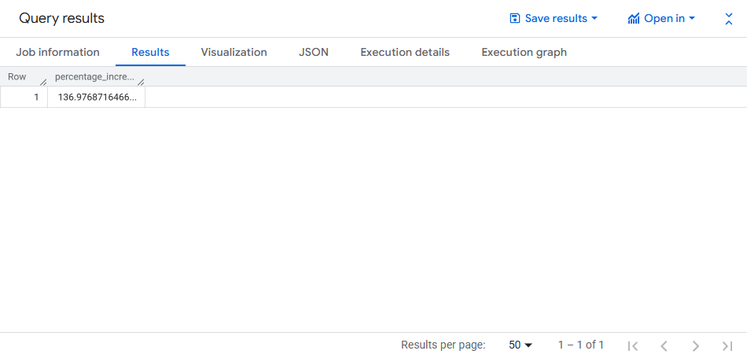
- Calculate the Total & Average value of order price for each state.

Hint: We want you to fetch the total price and the average price of orders for each state.

SYNTAX:
SELECT
c.customer_state,
SUM(p.payment_value) AS total_order_price,
AVG(p.payment_value) AS average_order_price
FROM `case_study`.`orders` AS o
INNER JOIN `case_study`.`payments` AS p
ON o.order_id = p.order_id
INNER JOIN `case_study`.`customers` AS c
ON o.customer_id = c.customer_id
GROUP BY c.customer_state
ORDER BY c.customer_state;

RESULT:

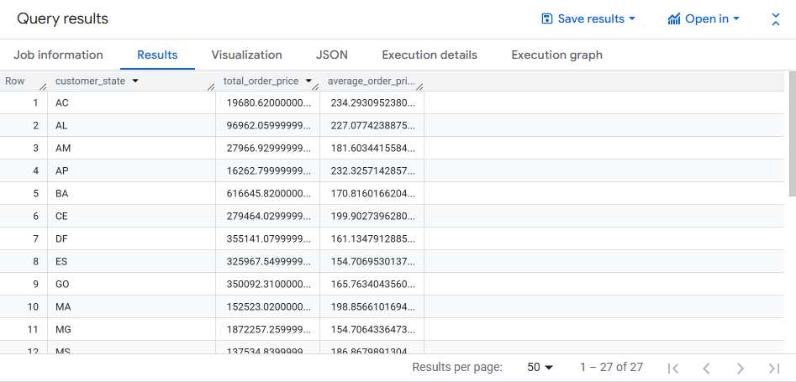

- Calculate the Total & Average value of order freight for each state.

Hint: We want you to fetch the total freight value and the average freight value of orders for each state.

SYNTAX:
SELECT c.customer_state,
SUM(o.freight_value) AS total_freight_value,
AVG(o.freight_value) AS average_freight_value
FROM `case_study.orders` AS o
INNER JOIN `case_study.customers` AS c
ON o.customer_id = c.customer_id
GROUP BY c.customer_state
ORDER BY c.customer_state;

RESULT:

- Freight value represents logistics cost, but since the dataset provides only total payment, freight-specific impact cannot be isolated.

V. Analysis based on sales, freight and delivery time.
A. Find the no. of days taken to deliver each order from the order’s purchase date as delivery time. Also, calculate the difference (in days) between the estimated & actual delivery date of an order. Do this in a single query.
Hint: You can calculate the delivery time and the difference between the estimated & actual delivery date using the given formula:
● time_to_deliver = order_delivered_customer_date - order_purchase_timestamp
● diff_estimated_delivery = order_estimated_delivery_date - order_delivered_customer_date

SYNTAX:
SELECT
order_id,
order_purchase_timestamp,
order_delivered_customer_date,
order_estimated_delivery_date ,
(order_delivered_customer_date - order_purchase_timestamp) AS time_to_deliver,
(order_estimated_delivery_date - order_delivered_customer_date) AS diff_estimated_delivery
FROM `case_study.orders`
WHERE order_delivered_customer_date IS NOT NULL;

RESULT:
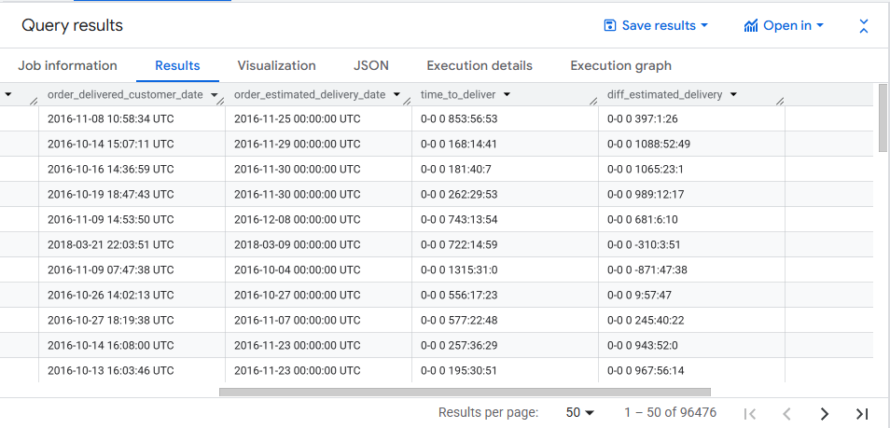
B. Find out the top 5 states with the highest & lowest average freight value.
Hint: We want you to find the top 5 & the bottom 5 states arranged in increasing order of the average freight value.

SYNTAX:
WITH state_avg_payment AS (
SELECT
c.customer_state,
AVG(p.payment_value) AS avg_payment_value
FROM `case_study.customers` c
JOIN `case_study.orders` o
ON c.customer_id = o.customer_id
JOIN `case_study.payments` p
ON o.order_id = p.order_id
GROUP BY c.customer_state
)
SELECT customer_state, avg_payment_value
FROM (
SELECT customer_state, avg_payment_value
FROM state_avg_payment
ORDER BY avg_payment_value ASC
LIMIT 5
)
UNION ALL
SELECT customer_state, avg_payment_value
FROM (
SELECT customer_state, avg_payment_value
FROM state_avg_payment
ORDER BY avg_payment_value DESC
LIMIT 5)
ORDER BY avg_payment_value ASC;

RESULT:
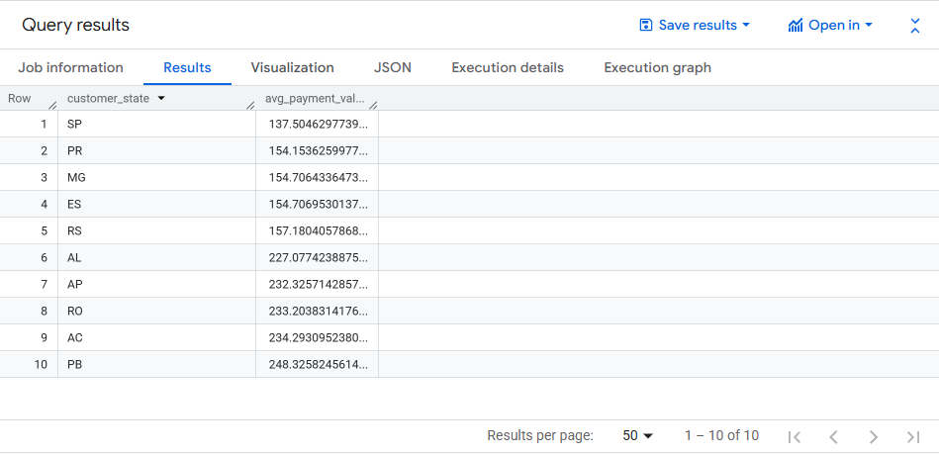

C. Find out the top 5 states with the highest & lowest average delivery time.
Hint: We want you to find the top 5 & the bottom 5 states arranged in increasing order of the average delivery time.

SYNTAX:
WITH state_avg_delivery AS (
SELECT c.customer_state,
AVG(DATE_DIFF(o.order_delivered_customer_date,o.order_purchase_timestamp,DAY)) AS avg_delivery_time
FROM `case_study.customers` c
JOIN `case_study.orders` o
ON c.customer_id=o.customer_id
WHERE o.order_delivered_customer_date IS NOT NULL
GROUP BY c.customer_state
)
SELECT customer_state,avg_delivery_time
FROM (
SELECT customer_state,avg_delivery_time
FROM state_avg_delivery
ORDER BY avg_delivery_time ASC
LIMIT 5
)
UNION ALL
SELECT customer_state,avg_delivery_time
FROM (
SELECT customer_state,avg_delivery_time
FROM state_avg_delivery
ORDER BY avg_delivery_time DESC
LIMIT 5
)
ORDER BY avg_delivery_time ASC;

RESULT:

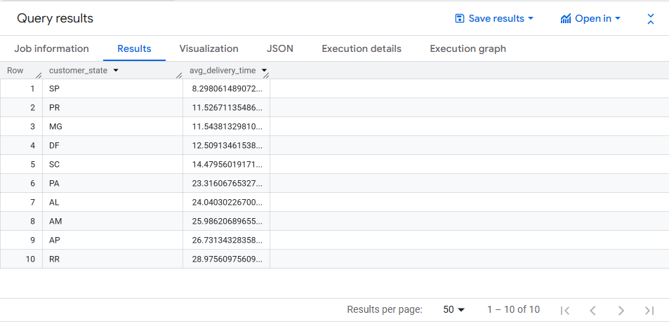

D. Find out the top 5 states where the order delivery is really fast as compared to the estimated date of delivery. You can use the difference between the averages of actual & estimated delivery date to figure out how fast the delivery was for each state.
Hint: Include only the orders that are already delivered.

SYNTAX:
WITH state_delivery_speed AS (
SELECT c.customer_state,
AVG (DATE_DIFF (o.order_estimated_delivery_date,o.order_delivered_customer_date,DAY))
AS avg_fast_delivery_days
FROM `case_study.customers` c
JOIN `case_study.orders` o
ON c.customer_id=o.customer_id
WHERE o.order_delivered_customer_date IS NOT NULL
GROUP BY c.customer_state
)
SELECT customer_state,avg_fast_delivery_days
FROM state_delivery_speed
ORDER BY avg_fast_delivery_days DESC
LIMIT 5;

RESULT:
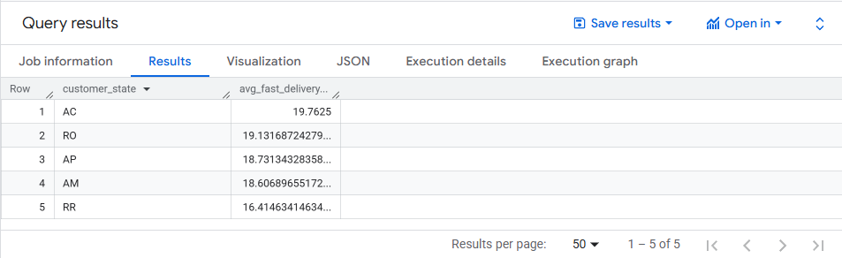

VI. Analysis based on the payments:
A. Find the month on month no. of orders placed using different payment types.
Hint: We want you to count the no. of orders placed using different payment methods in each month over the past years.

SYNTAX:
SELECT
EXTRACT(YEAR FROM o.order_purchase_timestamp) AS order_year,
EXTRACT(MONTH FROM o.order_purchase_timestamp) AS order_month,
p.payment_type,
COUNT(DISTINCT o.order_id) AS total_orders
FROM `case_study.orders` o
JOIN `case_study.payments` p
ON o.order_id=p.order_id
GROUP BY order_year,order_month,p.payment_type
ORDER BY order_year,order_month,p.payment_type;

RESULT:

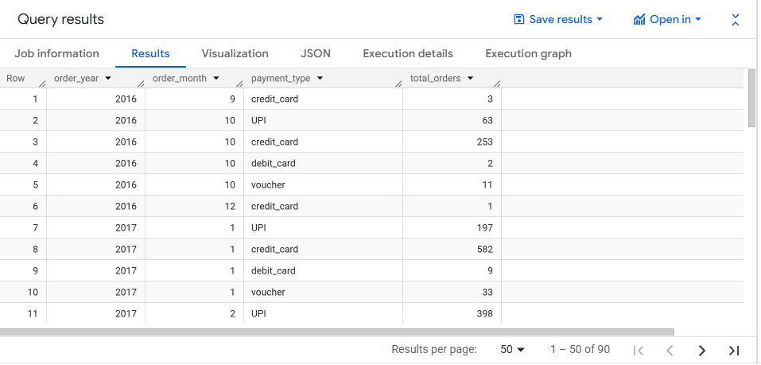

B. Find the no. of orders placed on the basis of the payment installments that have been paid.
Hint: We want you to count the no. of orders placed based on the no. of payment installments where at least one instalment has been successfully paid.

SYNTAX:

SELECT
p.payment_installments,
COUNT(DISTINCT p.order_id) AS total_orders
FROM `case_study.payments` p
WHERE p.payment_value>0
GROUP BY p.payment_installments
ORDER BY p.payment_installments;

RESULT:

